**Lecture 16**

Yum-Local RepoServer-LVM2

LVM

LVM stands for Logical Volume Manager, a system for managing disk partitions in Linux. LVM provides an abstraction layer over physical disks, allowing you to create and manage logical volumes that can span multiple physical disks. The main advantage of using LVM is that it makes it easier to manage and resize disk partitions, as you can create and resize logical volumes without having to physically move data on the disk.

Here are some of the key features of LVM:

1. Logical volumes: LVM creates a logical view of disk storage, allowing you to create and manage logical volumes.
2. Resizing: LVM makes it easy to resize logical volumes, either by expanding or reducing the size, without having to move data around.
3. Striping: LVM supports striping, which allows data to be spread across multiple physical disks for increased performance.
4. Snapshots: LVM supports snapshots, which are read-only copies of a logical volume that can be used for backup or testing purposes.
5. Mirrored volumes: LVM supports mirrored volumes, which provide data redundancy by duplicating data across multiple physical disks.
6. Physical volume management: LVM provides a unified way to manage multiple physical disks, allowing you to easily add or remove disks from a logical volume.
7. Flexibility: LVM provides a flexible way to manage disk storage, as you can create and manage logical volumes without being limited by the physical disk layout.

-

Yum local repository in Linux

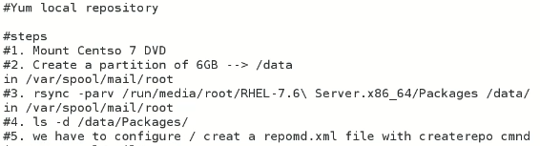

Mount CentOS 7 DVD à to connect local repository

* 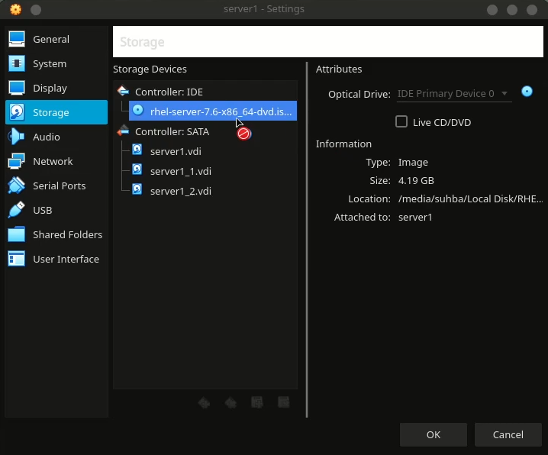
* Add ISO in VM à click on add optical drive
* (Remember first check the destination partition if it has required space available?)
* If enough space is not available, add sufficient disk space and create a mount point for the data from DVD to be copied.
* Discover the newly added disk with this command, (required in VmWare)
* 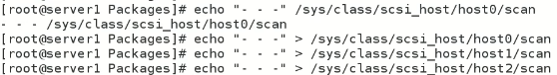
* It will discover newly added disk/partition without a need to restart the system.
* 
* Use rsync to copy packages directory
* $ rsync -parv //run/media<Package_directory_path> <destination_path>
* 
* Copying started
* 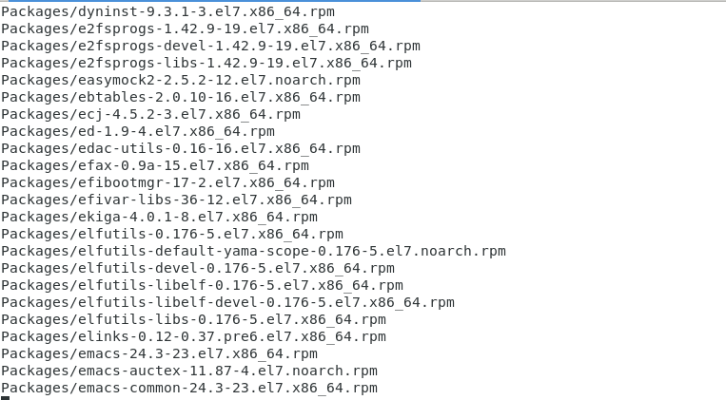
* Copy completed.
* 
* Now check the folder which received the Packages directory

Now this is local Repository

* Although we have all “rpm”packages in our “local repo” but the inventory file which is available in “bese repo” online is not available.
* We have to create it on local machine -à with a tool or command called “createrepo”
* If “createrepo” is not available à its needed to be downloaded and installed
* “createrepo” à creates repomd.xlm inventory file in the same directory where Packages directory containing all rpms is saved.
* The local repo/server is ready to be used.
* Now we have to use this local repo and the yum command should invoke this local repo offline just like it downloads and installs online packages.
* Now a locarepo file is to be created **local.repo**
* The file should be in “/etc/yum.repo.d”
* For the sake of learning move all the repo files to some other location except “local.repo” so that yum command always check “local.repo” for packages downloading and installation
* 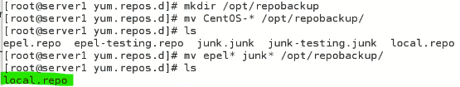
* Inside local.repo à
* 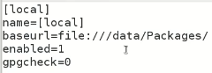
* gpgcheck=0 *integrity
* The path of baseurl can be browsed from browser too as it reacts as if it is an online source for the browser.
* The standard way is to use a command to prioritized a repo which is always invoked/used while running yum command
* $ yum –enablerepo-local install zsh à but it requires “priority plugin” to work
* To turn off and turn on repo à go to repo file and change value of “enable=”

|  |
| --- |
| In CentOS 8, a base repository is a collection of packages that are included in the default installation of the operating system. These packages are used to provide core functionality and are essential for the proper operation of the system.  To turn off a base repository in CentOS 8, you can temporarily disable it using the **dnf** command, which is the default package manager in CentOS 8. This can be done by using the following steps:   1. Open a terminal: Open a terminal or console window to run the **dnf** command. 2. Disable the base repository: To disable a base repository, you can use the following **dnf** command, replacing "repository-name" with the name of the repository you want to disable:   **dnf --disablerepo=repository-name**  For example, if you want to disable the "BaseOS" repository, you can use the following command:  **dnf --disablerepo=BaseOS**   1. Verify that the repository is disabled: You can verify that the repository has been disabled by running the following command:   **dnf repolist**  This command will display a list of all the repositories that are currently enabled, and you should see the repository you disabled marked as "disabled".  To turn on a base repository that has been disabled, you can simply run the same **dnf** command with the **--enablerepo** option, replacing "repository-name" with the name of the repository you want to enable:  **dnf --enablerepo=repository-name**  For example, if you want to enable the "BaseOS" repository, you can use the following command:  dnf --enablerepo=BaseOS |

**Hands on practice**

* 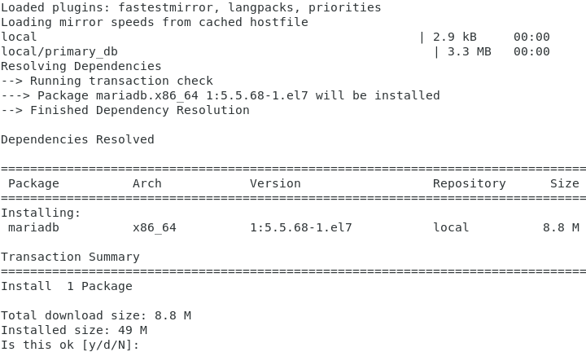

I encountered [Errno 14] curl#37 à this error was due to wrong address of repository in local.repo file.

* I fixed it à and instead of complete address à I just given the path of the directory which have all the rpm packages as shown below
* Graphical user interface, text, application

  Description automatically generated
* Before it the error was ,
* 
* Further working explained
* 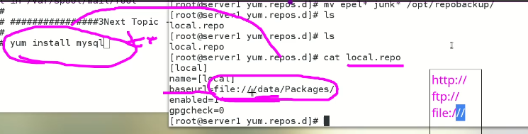
* “file://” protocol explained

|  |
| --- |
| * The "file://" protocol is used to access local files on a computer. It allows you to access files stored on your hard drive as if they were accessible from a web server. When you enter a file URL with the "file://" protocol in your web browser's address bar, the browser will display the contents of the file directly, rather than attempting to retrieve it from a remote server. * For example, if you have a file named "example.html" stored on your desktop, you can access it in your web browser by entering the following URL in the address bar: "file:///C:/Users/[Username]/Desktop/example.html". * Note that different web browsers may have different security restrictions when it comes to accessing local files using the "file://" protocol. Some browsers may prevent the display of local files for security reasons, or may limit the types of files that can be accessed in this way |

**LVM (Logical Volume Manager)**

LVM stands for Logical Volume Manager. It is a system for managing disk storage in a Linux environment. LVM provides an abstraction layer on top of physical storage devices, allowing you to create and manage logical volumes, which can be resized, split, and combined as needed, without having to worry about the underlying physical storage. This makes it easier to manage your storage and can also help you avoid downtime and data loss in the event of a disk failure.

* The partitions must be in LVM so that may be customised with LVM afterwards.
* Steps to create a “/common” partition as LVM
  1. Add a new disk à in VM add a new Virtual disk
  2. Make partition à through (fdisk 300 mb)
  3. Driver /dev/sdb is assigned à id 8e à LVM
     + Layers for LVM 1st layer PV à 2nd layer VG à 3rd layer LV
       - 1st layer PV (Physical Volume 700mb actual size of the HDD) at /dev/sdb1 à in LVM a new driver will be assigned as /dev/<volume_group_Name>/<logical_Volume_Name>
       - 2nd layer VG (Volume Group 700mb)
       - 3rd laver LV (Logical Volume 300 mb) à 300 mb is our requirement and 400mb is left purposely.
  4. Don’t format /dev/sdb1 à format will convert it into a normal partition which is not LVM
* Run this command in VirtualBox to discover newly added HDD without reboot
* 
* $ ls /dev/sd* à check all HDD attached.
* 

**Hands on practice**

* Create new partition with “fdisk /dev/sdb” à primary partition
* And change its id (recommended) à to list all possible IDs after “t” typle “L”
* 
* 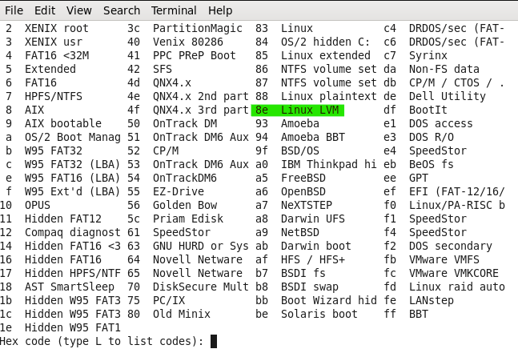
* “8e” Id is assigned
* 
* Then “w” to write the changes to RAM
* $ partx -a /dev/sdb or partprobe -s /dev/sdb (CentOS 7)
* (at this stage don’t format $ mkfs.ext4 as it will create a regular partition not LVM)
* **Start creating LVM layers**
  + Layer PV à $ pvcreate /dev/sdb1
  + 
  + Laver VG à $ vgcreate <volume_name> /dev/sdb1
  + 
  + Layer LV
  + $ lvcreate -L <size> -n <name> <VG_name>
  + 
  + To check,
  + 
  + Now this particular <device_driver> which is /dev/my_vol/lv1 can be formatted as usual
  + 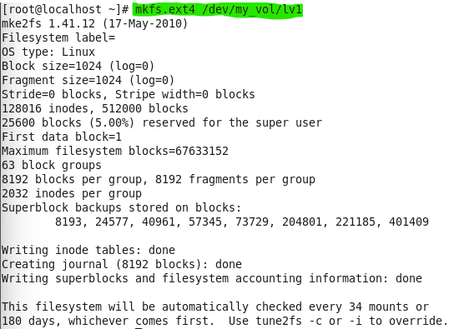
  + Now mount the partition
  + 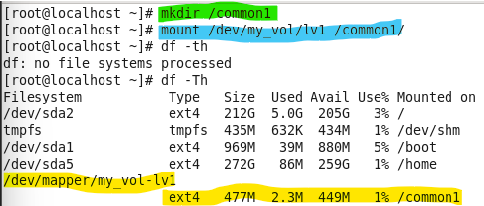
  + Now for persistence entry into “fstab”
  + 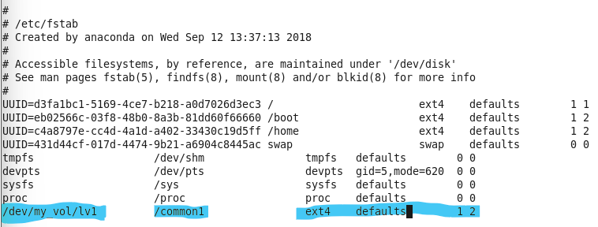
  + $ mount -a à to check and verify
  + Diagram, schematic

    Description automatically generated
  + No error show in “mount -a” à everything is oaky
  + 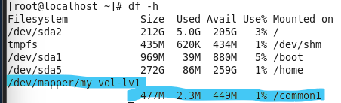

Now this LVM can be resized , extended etc accordingly à 200 mb more in this case

* + Tip $ lsblk à lists all available disks and partitons
* 